M. Sai Harshitha
192424408
CSA0701
SET- 6: Monthly Product Sales
1. Procedure to Create a Bar Graph
- Open Tableau Desktop and connect to the Product Sales dataset.
- Open a new worksheet.
- Drag Product Name to the Columns shelf.
- Drag Measure Values to the Rows shelf.
- Drag Measure Names to the Columns shelf (next to Product Name).
- In the Measure Values card, retain only:
  - January Sales
  - February Sales
  - March Sales
- Drag Measure Names to the Color option on the Marks card.
- Ensure the Marks type is set to Bar.
- Edit the chart title to "First Quarter Product Sales by Product".
- Rename the axes:
  - X-axis: Product Name
  - Y-axis: Sales
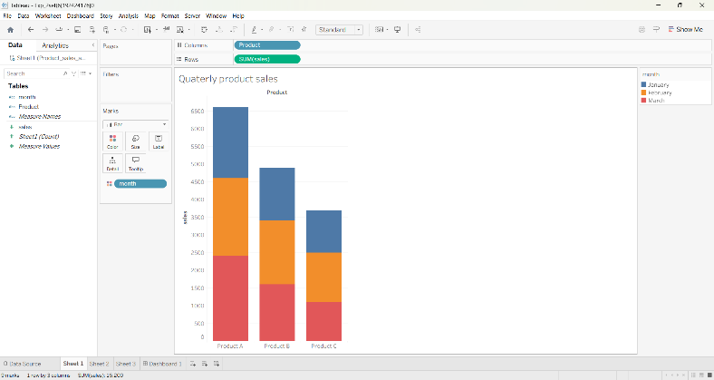

2. Procedure to Create a Stacked Area Graph
- Open a new worksheet.
- Drag Measure Names to the Columns shelf.
- Drag Measure Values to the Rows shelf.
- In the Measure Values card, keep only:
January Sales
February Sales
March Sales
- Drag Product Name to the Color option on the Marks card.
- Change the Marks type from Automatic to Area.
- Go to Analysis → Stack Marks → On.
- Edit the title as "Overall Sales Trend for All Products".
- Rename the axes:
- X-axis: Months
- Y-axis: Sales
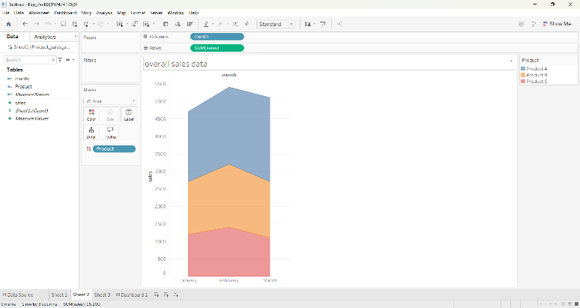

3. Procedure to Create a Table
- Open a new worksheet.
- Drag Product Name to the Rows shelf.
- Drag the following measures to the Text option on the Marks card:
- January Sales
- February Sales
- March Sales
- Alternatively, drag Measure Names to Columns and Measure Values to Text, keeping only the three monthly sales fields.
- Rename the worksheet title as "Monthly Product Sales Data".
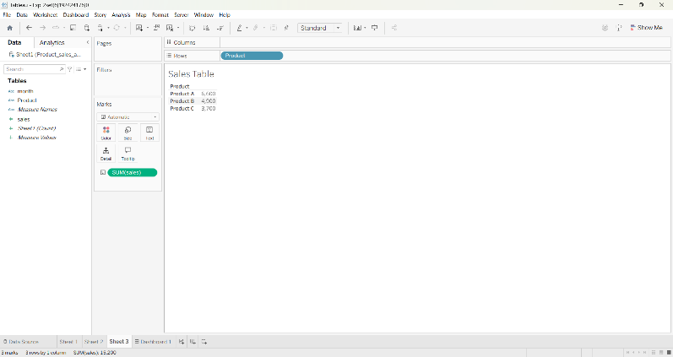

4. Procedure to Create a Dash Board
- Click the New Dashboard icon.
- Set the dashboard size to Automatic.
- Drag the following worksheets onto the dashboard:
- Grouped Bar Chart
- Stacked Area Chart
- Sales Table
- Arrange the worksheets neatly.
- Click Dashboard → Actions (optional) to enable interactivity.
- Rename the dashboard as "Product Sales Analysis Dashboard"
